# HABAGAT: A 2D ANIMATED FILM FOR IMPROVING THE COMMUNITY DISASTER PREPAREDNESS DURING TYPHOON EVENTS

A Capstone Project

Submitted to the Faculty of

National University-Manila

College of Computing and Information Technologies

In Partial Fulfillment of the Requirements for the Degree

Bachelor of Science in Information Technology

With Specialization in Multimedia Arts and Animation

By

**MARIA JEARAND BULAWAN**

**ABDALLAH MOHAMMED KASHTA**

**FRANCHESKA NICOLE G. LIMSON**

**JUANCHO RAMORES III**

**PROF. AVONN. C. NOVA**

Capstone Adviser

**JUNE 2023**

# CHAPTER 1 INTRODUCTION

This chapter discussed the introduction of the study that includes the project context, purpose, and description, objectives, and scope and delimitation.

The Philippines is highly vulnerable to climate disasters due to its geography, politics, economy, and society. The nation experiences an average of 20 typhoons annually, and climate change is increasing the frequency and magnitude of these events. Rapid and unplanned urbanization exacerbates vulnerabilities in Metro Manila. Disaster Risk Reduction Management frameworks in the Philippines and National Capital Region for 2020 typhoons have improved since Republic Act No. 10121. [1] The study was conducted to identify the factors that affect perceived preparedness of super typhoons, using a three-domain approach: physical, cognitive, and organizational. [2] Society's disaster preparedness is low despite public hazard education efforts. Respondents' cognitive factors were high towards typhoon preparedness, with perceived severity, self-efficacy, and response efficacy being key determinants. [3] Community members in Zambales are prepared for various disasters, with varying levels of awareness and perception of different hazards. Proposed community extension programs should provide information about disaster causes and consequences to inform disaster risk reduction and mitigation strategies. [4]

The Philippine government has implemented disaster risk reduction and management efforts, including the Disaster Risk Reduction and Management Act and Project NOAH for typhoon forecasting. The government has also established a master plan for flood management until 2035 and is funding various flood control projects. Rehabilitation efforts after disasters have been slow, highlighting the need for private citizens and organized efforts to step up relief work. [5] The Philippine Disaster Resilience Foundation (PDRF) launched Project KoNeK to enhance disaster readiness through public-private partnerships and local government official training. [6] To prepare for natural disasters, individuals and families should discuss survival measures, have insurance coverage, create a social network for disseminating information, and learn important skills such as first aid and CPR. [7] Before a typhoon hits, secure your home, buy personal safety gear, have a safety plan for pets, withdraw cash, and ready technology. After a typhoon, assess any damage to your home, prioritize safety, and begin cleaning debris, while prioritizing self-care and preparing for future events. [8]

The Philippines frequently experiences natural disasters, from typhoons and floods to volcanic eruptions and earthquakes, which can cause loss of lives, property, and infrastructure damage. The United Nations Development Programme (UNDP) and the Australian government launched Shield, a disaster mitigation initiative, to strengthen the country's resilience against hazards and climate change. Shield supports the GeoRiskPH centralized database, containing information on the risks posed by different types of disasters, which can be used to inform preparedness and mitigation plans. [9] Residents of a Teen/Young Adult Transitional Home impacted by Typhoon Odette work together to clear waste and receive stress debriefing activities to cope with anxiety caused by the typhoon. [10] Over 300,000 villagers have fled to safety following Typhoon Odette, causing over $3.2 million in damage to crops, livestock, and machinery. [11]

Typhoon Yolanda hit the Philippines in 2013, causing thousands of deaths, injuries, and displacement, leaving Tacloban City in ruins. Numerous foreign governments and aid organizations have pledged assistance to the recovery efforts. [12] Tacloban was severely affected by Super Typhoon Yolanda in 2013, causing immense destruction, killing over 6,000 people and displacing millions. Relief efforts were slow, and rebuilding cost was estimated at $5.8 billion. After years, the city is still recovering, and life has resumed. World Vision responded to the disaster with emergency relief and recovery efforts in affected areas where they work, and still offer continued support through their programs today. [13] Super Typhoon Rolly hit the Philippines in 2020, affecting over 19 million people, and hampering recovery from three previous storms and the pandemic. [14] Government budget cuts and slow response further increased economic impacts. Farmers and rural communities struggle to recover without promised aid after series of deadly storms. The government's lack of climate adaptation policies exacerbates agricultural damages and debt. [15] The Philippines is highly vulnerable to natural disasters due to climate change, and economic struggles from the pandemic increase the risk of suffering and death. The government has implemented disaster management and climate change adaptation policies. The Philippines prioritizes the development of resilient and green infrastructure, as well as establishing structures and institutions to coordinate international humanitarian teams and donations during natural disasters. The Enhanced Defense Cooperation Agreement (EDCA) has advanced relations on humanitarian assistance between the Philippines and the United States. [16]

Almost 10 million people were affected by Super Typhoon Odette, with 1.7 million homes damaged. Pre-emptive evacuation measures helped reduce casualties. The Philippine Disaster Resilience Foundation (PDRF) is the primary coordinator for private sector initiatives in disaster preparedness, response, and recovery in the Philippines. The Philippines and United Nations agencies have partnered to create an Anticipatory Action project, which allocates funds for early action against floods and typhoons. Civil society in vulnerable countries are urging for increased funding for climate change adaptation and humanitarian efforts. [17] The pandemic has impacted response operations to destructive typhoons, requiring creativity and flexibility to address additional needs. [18] Climate-induced disasters have caused a spike in human trafficking cases in the Philippines. [19] The Philippines bears the brunt of climate change impacts such as devastating typhoons, leading to the call for climate justice. [20] Typhoon Rolly caused devastation to several islands in the Philippines, displaced over 112,000 people, and left 21 dead. Salvador Manrique lost his youngest son, and his wife and eldest child are missing. [22]

Super Typhoon Yolanda caused severe damage to Tacloban, Philippines. Joanna Vasquez Arong's short film essay explores how the community coped and exhibited resilience following the disaster. [23] The local animation industry in the Philippines has struggled due to lack of demand and network hesitance to finance costly projects. However, Filipino animators have become a creative hub for foreign studios and contributed to the making of famous animated films like Finding Nemo. Director Avid Liongoren shares his experience in creating his own animation studio and the production of his animated film, Hayop Ka!. Liongoren hopes to contribute to the growth of the country's animation industry. [24]

## PROJECT CONTEXT

In the past few years, Sampaloc, Manila, has faced severe consequences from typhoon occurrences. These calamities can cause significant damage to the community, resulting in loss of lives, property damage, and disruption of essential services within the community. It is clearly stated that there is an urgent requirement to enhance the community's readiness and response plans to minimize the negative impacts of typhoons.

To address this problem, a creative solution is proposed in developing a 2D animated film called Habagat. This project aims to educate and engage the residents of Barangay 407, Zone 42, Sampaloc about disaster preparedness during typhoons. Through the animated film, the community will show about crucial safety measures, evacuation protocols, and how to respond effectively to emergencies when confronted with a typhoon. The film's innovative approach aims to raise awareness and promote better disaster readiness among the residents.

The proposed 2D animated film entitled “Habagat” aims to achieve several key objectives in raising awareness and promoting disaster preparedness among the residents of Barangay 407, Zone 42, Sampaloc, Manila regarding typhoon events. The film will educate viewers on essential preparedness measures, evacuation procedures, and the significance of community cooperation during disasters. It will also emphasize the importance of staying informed through early warning systems and official advisories. By addressing these aspects, the animated film seeks to empower the community to better handle typhoon situations and minimize potential risks and damages.

The implementation of the “Habagat” 2D animated film project will involve a collaborative effort with local disaster management agencies, community leaders, and experts. The process will include extensive research, scriptwriting, animation production, voice acting, and sound design. The film's distribution will be widespread, reaching the residents of Sampaloc through various channels such as schools, community centers, and online platforms. Community screenings will also be organized to encourage engagement and discussion on disaster preparedness and response strategies. By following these steps, the project aims to effectively raise awareness and educate the community about the importance of being prepared for typhoon events and promoting cooperation during emergencies.

The 2D animated film “Habagat” aims to empower the residents of Sampaloc, Manila, with the knowledge and tools they need to better prepare for typhoon events. With improving community disaster preparedness, it is anticipated that the project will reduce the loss of life and property during typhoons and enhance the overall resilience of the community in the face of natural disasters. Furthermore, the film's engaging and informative nature will likely foster a culture of preparedness and cooperation, leading to a safer and more secure community.

## 1.2 PURPOSE AND DESCRIPTION

In producing the 2D animated film “Habagat” is about helping people to understand the importance of disaster preparedness when typhoon occurs in the area. The animated film was based on the disaster preparedness plan of the residents in Barangay 407, Zone 42, Sampaloc, Manila which intends to provide entertainment to the Filipinos, and it is also conceptualized and designed to raise public awareness and education in reducing loss of life, personal injuries, and damage from storms. This capstone project aims to address on developing strategies and initiatives to enhance the ability of communities to effectively respond to and mitigate the impact of the typhoons.

## 1.3 OBJECTIVES

**General Objective**

This research project seeks to create an educational animated film that will raise awareness about disaster preparedness plan of the residents of Sampaloc, Manila during typhoon disasters in the Philippines, and to implement the typhoon disaster preparedness plan of the Barangay 407, Zone 42, Sampaloc, Manila.

**Specific Objectives:**

The following are the specific objectives of the study:

1. Raise Awareness: The primary objective of the 2D animated film is to raise awareness among the residents of Sampaloc, Manila, about the importance of disaster preparedness and the potential risks associated with typhoon events.
2. Educate on Preparedness Measures: The film will provide valuable information on disaster preparedness measures that individuals and families can take before a typhoon strikes. This includes creating an emergency plan, securing property, and preparing emergency kits.
3. Inform about Evacuation Procedures: The film will outline clear and easy-to-follow evacuation procedures to ensure that residents know how to evacuate safely and efficiently when the need arises.
4. Promote Community Cooperation: The animated film will emphasize the significance of community cooperation during disaster situations, encouraging residents to support one another and work together to protect each other's safety.
5. Encourage Early Warning System Awareness: The project will highlight the importance of paying attention to early warning systems and official advisories from local authorities to stay informed and make informed decisions.

## 1.4 SCOPE AND DELIMITATION

**SCOPE**

The scope of the study focuses on improving the community disaster preparedness during typhoon events in Barangay 407, Zone 42, in Sampaloc, Manila. The study aims to promote the importance of disaster preparedness plan before a huge typhoon will hit the in-danger areas throughout the 2D animated film. The animated film will only use Tagalog as its main language, and an English subtitle. This study will be exploring the effectiveness of the 2D animated film to the audiences through the utilization of questionnaires by Google forms to the viewers, the collected data will be analyzed using statistical treatment specifically descriptive statistics.

**DELIMITATION**

This study will focus on developing and the evaluation of the Habagat, a 2D animated film as a means of promoting the importance of preparedness plan before a super typhoon strikes. The study will be exploring the impact of the 2D film animation to improve the community response in typhoon events through getting the insights of the audience. The study will be considering other forms of media or interventions that may also help for promoting public awareness and education to the audience.

The Habagat animated film is a 5-minute duration film. It will only use 2D film animation with a maximum of 15 frames per second rate by using Clip Studio Paint, and Adobe Photoshop Pro. The study will not be addressing the social, political, and economic factors that play significant roles in shaping and influencing disaster preparedness efforts.

**CHAPTER 2**

**REVIEW OF RELATED LITERATURE AND SYSTEMS**

This chapter mainly gives the different research and literatures, which have notable relation on the variables included in the research. Moreover, this chapter will discuss the related literatures of typhoon disaster events in some of the affected areas in the Philippines. The literatures of this study were taken in articles, journals such as PDF and other existing theses and dissertations that are useful for the advancement of the study. Ethical consideration is also included.

**2.1 RELATED LITERATURES/STUDIES**

According to this study, the Philippines is highly vulnerable to climate disasters due to its geography, politics, economy, and society. The nation experiences an average of 20 typhoons annually, and climate change is increasing the frequency and magnitude of these events. Rapid and unplanned urbanization exacerbates vulnerabilities in Metro Manila. This thesis uses a case study approach to assess Disaster Risk Reduction Management frameworks in the Philippines and National Capital Region for 2020 typhoons. Findings show Disaster Risk Reduction Management has improved since Republic Act No. 10121 but can still tackle root causes of vulnerabilities. The transformation as liberation model is used to generate policy recommendations, such as increasing participation and inclusivity, formalizing vulnerability measurements, and reframing climate change and disaster risks. (Granstrom, S., 2022). [1]

The study was conducted to identify the factors that affect perceived preparedness of super typhoons. The approach includes three broad domains of ergonomics: physical, cognitive, and organizational. Physical domain includes a structural and functional analysis of buildings, roads, and other infrastructure supporting disaster response. Cognitive domain includes emergency knowledge and communication systems. Organizational domain includes coordination, planning, and decision-making based on roles and responsibilities of relevant stakeholders. The findings of the study can be utilized by policymakers to improve preparedness and mitigation strategies in the face of super typhoons. (Gumasing, M., Prasetyo, Y., Ong, A., Nadlifatin, R., & Persada, S., 2022). [2]

In this context, typhoons are a common disaster in the Philippines causing injury, death, and property damage. Society's disaster preparedness is low despite public hazard education efforts. The grand mean and standard deviation revealed high cognitive factors for perceived severity, susceptibility, self-efficacy, and response efficacy towards typhoon preparedness. Pearson's r, p-value and determination coefficient showed a positive relationship to planning, mitigation, and response. The respondents' cognitive factors were high towards typhoon preparedness, with perceived severity, self-efficacy, and response efficacy being key determinants. (Mideksa, S., 2021). [3]

This descriptive survey research aims to measure disaster awareness and preparedness of the barrio community in Zambales. The study had 480 respondents who were asked about their level of awareness about different disasters. Respondents were highly aware of typhoons but moderately aware about tsunamis and storm surges. The perception of respondents about the hazard level of different disasters also varied. Barrio community members are prepared for various disasters, including earthquakes, strong typhoons, landslides, fire, flood, and volcanic eruptions. The level of disaster awareness has a moderately positive correlation with disaster preparedness. This study serves as a baseline to integrate disaster science and management in basic and higher education levels. Proposed community extension programs should provide information to local communities about disaster causes and consequences. This research outcome can inform disaster risk reduction and mitigation strategies. (Rogayan, D., Jr., 2020). [4]

In this article, the metropolitan area of Metro Manila, with over 13 million residents, has long been plagued with flooding problems. In response, the Philippines government has developed a strong disaster management system since Tropical Storm Ondoy in 2009. This includes the Disaster Risk Reduction and Management Act and Project NOAH for typhoon forecasting. The government has also put in place a master plan for flood management until 2035 and is funding numerous flood control projects to help address the issue. However, rehabilitation efforts after disasters have been slow, highlighting the need for private citizens and organized efforts to step up relief work. The Philippines is among the top five countries most vulnerable to natural hazards and should work harder to improve its disaster readiness. (Gamboa, R., 2022). [5]

In this related literature, the Philippine Disaster Resilience Foundation (PDRF) launched Project KoNeK. The project conducted simulation exercises with local government officials from vulnerable barangays across the country. Project KoNeK's primary objectives were to test the readiness of local government officials for disasters, assess their knowledge on contingency plans, evacuation procedures, and coordination with stakeholders, and to build their disaster risk reduction and management (DRRM) capabilities. Through the project, PDRF also aimed to establish public-private partnerships to ensure effective DRRM plans are in place and can be implemented whenever needed. (PDRF boosts QC barangays' disaster preparedness – Philippines, 2022). [6]

By this blogsite, natural disasters are a part of life, and the Philippines is no stranger to them. It is important to be prepared for typhoons, particularly during the current pandemic. Discuss survival measures with family members, and make sure everyone knows what to do in case of an emergency. Make sure to have insurance coverage and try to reduce unnecessary expenses to boost emergency funds. Establish a social network for disseminating information. Make sure everyone is up to date with their COVID-19 vaccinations and learn important skills such as first aid and CPR. Put together an emergency kit containing essential supplies such as skin creams, face masks, and charged electronic devices. Stay informed about the situation and take necessary precautions to stay safe. Put away any items that may cause harm or injuries in case of disasters. Be sure to remain calm and practice healthy coping strategies to manage stress or anxiety. Have a plan of action in case of financial emergencies. Keep important documents such as insurance policies in waterproof envelopes. Stay connected with banks and credit companies in case of financial assistance. (Zoleta, V., 2022). [7]

In accordance with this passage, before a typhoon hits, it is important to secure your home, buy personal safety gear, have a safety plan for pets, withdraw cash, and readying technology. Consider investing in solar-powered and waterproof equipment and determine where to stay based on the severity of the typhoon. Stay safe during a typhoon by not looking outside and ensure comfort with blankets and games. After the typhoon, check supplies and food for safety. After a severe weather event, individuals should assess any damage to their home, prioritize safety, and begin cleaning up debris. It is important to prioritize self-care and prepare for future events. (Yuvallos, A., 2022). [8]

As stated in this article, the Philippines is a country that frequently experiences natural disasters, from typhoons and floods to volcanic eruptions and earthquakes. These events can lead to loss of lives and property and can cause long-term damage to infrastructure. In response to these challenges, the United Nations Development Programme (UNDP) and the Australian government have launched Shield, a disaster mitigation initiative that aims to strengthen the country's resilience against hazards and climate change. The initiative will provide support for the GeoRiskPH centralized database, which is used for disaster planning. The GeoRiskPH database contains detailed information on the risks posed by different types of disasters, including their likelihood and potential severity. This data can be used to inform disaster mitigation plans and help local authorities prepare for future events. The database also provides access to tools that can be used to create detailed risk maps. (Data vs disaster: Inside the Philippines' natural emergency preparedness programme). [9]

Just as said in this context, residents of a Teen/Young Adult Transitional Home in an area impacted by Typhoon Odette work together to clear waste, as depicted in photos of the facility's front yard, parking area, and roof. A separate photo shows damage to the home's washroom. On December 21, 2021, stress debriefing activities were held for residents. The activity was conducted to help them cope with anxiety caused by the typhoon and to continue to build their future. Though the typhoon caused damage to the Teen/Young Adult Transitional Home, the staff and residents were prepared and safe. (Andrade, J. (2022). [10]

As in this point of view, over 300,000 villagers had fled to safety, and the death toll stands at 375 with 56 people missing. President Rodrigo Duterte declared a "state of calamity" in six regions. Typhoon Odette displaced over 481,000 people in the Philippines, causing widespread flooding and damage. The storm devastated the island of Siargao, where it first made landfall. At least 94 people have died on the island of Bohol. Photos show the outcome of Super Typhoon Odette in various parts of the Philippines, including displaced residents taking shelter in evacuation centers and extensive damage to trees and buildings. Numerous foreign governments and aid organizations have pledged assistance to the recovery efforts. Super Typhoon Odette has caused $3.2 million in damage to crops, livestock, and machinery in the Philippines, catching government agencies off guard. President Duterte has pledged funds for disaster cleanup, acknowledging the country's vulnerability to climate change impacts. Typhoon Odette ravaged Cebu province in the central Philippines, causing damage to homes and prompting residents to recover their personal belongings. (McCarthy, J., & Storel, M., (2021). [11]

As reported by the news, Typhoon Yolanda hit the Philippines in November 2013, causing 7,360 thousand deaths or disappearances, and damaging or washing away 1.1 million houses. More than 27,000 people were injured, 4 million were displaced, and Tacloban City was left in ruins. Photographer Ted Aljibe visited the disaster areas after five years to capture the after-effect scenes in Tacloban City, where the typhoon destroys. Tacloban was one of the hardest-hit areas, and relief efforts were slow. 4,000 people in the city died, and the cost of rebuilding was estimated at $5.8 billion. Thousands of people were still living in temporary shelters a year on, and four million people were still displaced. After five years, the city is slowly returning to normal, and scenes of daily life, such as Rizal Street and the junction of Burgos and Real streets, have resumed. Women still carry religious statues by the roadside in Tolosa, and roadside shelters can see in Anibong district and Justice Romualdez. (Aljibe, T., 2018) [12]

As stated in this review, Super Typhoon Yolanda struck the Philippines on November 8, 2013, causing massive destruction and displacement, killing over 6,000 people, and affecting over 14 million people across 44 provinces with overall damage estimated at $5.8 billion. World Vision provided aid and relief to affected families. Typhoon Yolanda hit the Philippines in November 2013, causing devastation to areas where World Vision works. World Vision responded with emergency relief, recovery, and rehabilitation efforts. World Vision's 2022 operating expenses were mainly used for programs benefiting those in need. They are an open book and accountable through independent reviews. (Reid, K., 2023). [13]

In accord with the topic, at least 10 people have died, and 19 million people may be affected by Super Typhoon Rolly in the Philippines. Emergency response teams, relief supplies, and personal protective equipment have been deployed in the Philippines ahead of the arrival of Super Typhoon Rolly. However, funds for disaster emergencies have been decrease due to the pandemic. People in the Philippines are still recovering from the impact of three previous storms in October. (Typhoon Goni: Philippines hit by year's Most powerful storm. (2020). [14]

According to the context, farmers and rural communities in the Philippines are struggling to recover without promised aid after a series of deadly storms. This has prompted calls for the government to find climate adaptation policies that reduce future damage. The new Marcos government's budget cuts to weather forecasting are affecting disaster response in the Philippines, with recent typhoons causing significant agricultural damage and leaving farmers struggling with debt. The government's slow response and inadequate support may worsen the economic impact of climate change. Farmers in the Philippines are calling for relief and subsidies after recent storms have destroyed crops. Past administrations are accused of ignoring the environmental impact of mining policies. (Beltran, M., 2022). [15]

From this point of view, the Philippines faces natural disasters such as typhoons, earthquakes, floods, and volcanic eruptions. Climate change has increased the risk of more frequent and intense disaster events, making the Philippines highly vulnerable. Poverty and economic decline due to the COVID-19 pandemic have only further elevated the risks of suffering and death from these natural disasters. The Philippine government has implemented disaster management and climate change adaptation policies. It is prioritizing the development of resilient and green infrastructure, as well as establishing structures and institutions to coordinate international humanitarian teams and donations during natural disasters. This involves involvement from national, provincial, and local government as well as international agencies. The United States has historically been involved in helping the Philippines during times of disaster. The Enhanced Defense Cooperation Agreement (EDCA) has advanced relations on humanitarian assistance as well. (2021 Philippines Disaster Management Reference Handbook - Philippines. (2021). [16]

In this context, almost 10 million people were affected by Super Typhoon Odette, with 1.7 million homes damaged. Pre-emptive evacuation measures helped reduce casualties. PDRF is the primary coordinator for private sector initiatives in disaster preparedness, response, and recovery in the Philippines. They mobilize member companies to provide aid during disasters, and their efforts are essential to addressing humanitarian needs. The Philippines and United Nations agencies have partnered to create an Anticipatory Action project, which allocates funds for early action against floods and cyclones. The project covers up to 54,100 households, with a focus on MSMEs to create sustainable recoveries after disasters. The Philippines integrates climate change adaptations with disaster risk reduction, but implementation challenges remain. Civil society in vulnerable countries are urging for increased funding for climate change adaptation and humanitarian efforts, including the private sector playing a critical role in building resilience. (Gabaldon, V., 2022). [17]

The study investigated how the pandemic has impacted response operations to destructive typhoons. It revealed that the pandemic generated additional needs that required creativity and flexibility to be addressed. The strict adherence to health guidelines and the use of digital technologies and remote work were necessary. To address the additional needs, it was important to develop innovative ways while maintaining the health and safety of responders and survivors. The intersection of these concurrent disasters highlights the need to consider compound risks in response plans. This entails considering the potential for simultaneous disasters when assessing risks and developing plans for response. (Gonzalo Ladera, L. A., & Tiemroth, A., 2021). [18]

As the stated report, climate-induced disasters have caused a spike in human trafficking cases in the Philippines, according to a United Nations Office on Drugs and Crime (UNODC) report. Typhoons have had a devastating effect on farming and fishing communities, and the frequency of climate-related disasters has doubled in recent years. The resulting displacement and loss of livelihoods have exacerbated the problem of human trafficking in the country. (Chi, C., 2023). [19]

According to the article, the Philippines, despite contributing very little to global emissions, bears the brunt of climate change impacts such as devastating typhoons. This has led to the call for climate justice, yet the government's resilience rhetoric conceals its inefficiency and inaction, leading to tragic consequences like loss of lives. The Philippines recently faced devastation from Typhoon Rolly, with disrupted communication and inadequate disaster response. The country needs strong leadership that demands accountability for climate change from the global north. Donations are accepted to help with relief efforts. (Murga, A., 2022). [20]

In this point of view, Super Typhoon Henry is expected to enter the Philippines' jurisdiction on Wednesday. The typhoon could bring high winds and rough seas along the northern and eastern seaboard of Luzon. (Cabico, G. K., 2022). [21]

In keeping with the news, Salvador Manrique tried to save his family from the flash flood caused by Typhoon Rolly in the Philippines, but his youngest son, Samuel, died, and his wife and eldest child are missing. The storm has displaced over 112,000 people and left 21 dead. A powerful typhoon has hit the Philippines, causing devastation to several islands. Stranded people are waiting for rescue, and a town suffers 90% damage. (Simonette, V., 2020). [22]

In this article, Joanna Vasquez Arong's short film essay explores how the community in Tacloban, Philippines coped with the devastation caused by Super Typhoon Yolanda. The film interweaves personal experience with stories from locals, providing an insightful look into the aftermath of the typhoon. The Philippines is especially susceptible to natural disasters, and mismanagement of these crises continues to persist. Despite this, the resilience of the people of Tacloban is on full display in Joanna Vasquez Arong's film. (Adobo Magazine., 2020). [23]

By this context, the first motion pictures in the Philippines were introduced in 1897. Animated shorts and the first feature-length animated film followed in 1978. Despite the potential of the local animation industry, it has struggled to gain acceptance due to lack of demand from domestic audiences and network hesitance to finance costly projects. Filipino animators have become a creative hub for foreign studios through subcontracted labor, with companies like Cartoon Network, Toei Animation, Nintendo, Sega, and Walt Disney-owned Pixar Animation Studios. In fact, Finding Nemo was composed mostly of Filipino animators. A Filipino animator shares his journey of doubt and struggle in making his personal story relevant in the global stage. The local animation industry is slowly gaining traction and recognition through festivals and independent filmmaking. Director Avid Liongoren shares his passion and experience in creating his own animation studio and making a quirky film. Director Avid Liongoren's animated film, Hayop Ka!, is the first Filipino feature-length animation to stream on Netflix. Liongoren hopes to contribute to the growth of the country's animation industry. The person is interested in starting a venture to benefit the community and the planet. During free time, they enjoy learning about human interest, pop culture, lifestyle, wellness, and mental health. (Commoner., 2021). [24]

**2.2. RELATED ANIMATED SHORT FILMS**

Table 1. Gap Analysis Table of Related Animation Short Films

|  |  |  |  |
| --- | --- | --- | --- |
| **Film Animation Title** | **Bagyo at Baha | Disaster Preparedness** | **Animated video on ‘Disaster Preparedness’** | **Bagyo Experience | Pinoy Animation** |
| **Duration** | 1:21 Minutes | 2:49 Minutes | 9:55 Minutes |
| **Dialogue** | x |  |  |
| **Narration** |  | x |  |
| **Type of Animation** | 2D Animation | 2D Animation | 2D Animation |
| **Typhoon Disaster Preparedness Plan** |  |  | x |
| **Evacuation Plan** | x |  |  |
| **Vulnerability** | High | High | High |
| **Emergency Disaster** | x | x |  |

Table 1 lists the analysis of related animated films, showing different scopes of the film including the typhoon disaster preparedness plan, evacuation procedures, how vulnerable the area, and when an unplanned emergency disaster occurs. Furthermore, it shows various kinds of animation, including 2-D animation, duration of the short film, dialogue, and narration.

**Bagyo at Baha | Disaster Preparedness**

An informative animation by Knowledge Channel features different types of disasters, providing knowledge on disaster preparedness during Typhoon and Flood. This infomercial demonstrates what you should do before, during, and after the typhoon lands in your place. Moreover, the main idea of surviving a storm takes place makes the important concern about being aware of expected outcomes, knowing which actions are required, being always observant, locating appropriate locations, and seeking help from the assigned individuals.

**Animated video on ‘Disaster Preparedness’**

An animation film that focuses on the evacuating your own place for your safety and enforcing orders from the leader of the group. The moral of the story indicates the things that should be always prepared, and what should do before the disaster falls on a specific location, during the typhoon disaster, and after the storm came. Also, it appears that the people should learn from their past experiences whereas this typhoon disaster happened in the place before.

**BAGYO EXPERIENCE | Pinoy Animation**

In this Filipino animated short film shares the experience of a real-life person during a typhoon located in Antipolo, Rizal in the Philippines. The film expresses the emergency, and unexpected situations that you will encounter during a Typhoon and Flood. Moreover, it aims when an emergency disaster happens, immediately think of an emergency evacuation plan to leave the flooding area for the safety of the people.

**SYNTHESIS**

**HABAGAT: A 2D animated film for Improving Community Disaster Preparedness during Typhoon Events** is a short, animated film that aims to increase readiness of communities for typhoon events in the Philippines. Moreover, it addresses the typhoon disaster readiness strategy within a particular region. The primary focus of this film is to improve preparedness levels among communities during typhoon seasons. In addition, it will display the ideal solutions for individuals in a typhoon-prone-area in the country.

Being in the Pacific Ring of Fire puts the Philippines at risk for typhoons. The improvement of typhoon disaster preparedness in the Philippines is necessary to decrease loss of life and property damage during typhoon seasons. Most of the areas that are affected of the typhoon are houses near to the river, low areas, informal settlers, rice field. By doing these emergency practices, the country’ Philippines can work on its preparation for typhoon disasters while limiting their effects for both Filipino citizens, and organizational structures and facilities.

# CHAPTER 3 TECHNICAL BACKGROUND

This chapter presents the technology to be used and technical description for the proposed project.

## 3.1 DETAILS OF THE TECHNOLOGY TO BE USED

This project desires to create a 2D animated film that aims to promote awareness in improving the community disaster preparedness during typhoon events through developing an inspirational film animation that will influence the residents of Sampaloc, Manila to use their platforms in saving the community’s current living. The film animation is based on the disaster preparedness plan of the community of Barangay 407, Zone 42, Sampaloc, Manila. This project will be using various available software and hardware devices as a way of executing this project.

**SOFTWARE**

Table 1. Software Requirements

|  |  |
| --- | --- |
| **Software** | **Specification** |
| **Windows Operating System** | Windows 10 Pro is the minimum specification requirement for producing a film animation. |
|  |  |
| **Desktop Applications** | |
| **Clip Studio Paint** | Intel and AMD processor with 64-bit support, 3.60 GHz, or faster processor. RAM: 16 GB. HDD: 4 GB of storage space. GPU: NVIDIA GeForce RTX 3060 and 2 GB of memory. Windows 10 Pro (64-bit) version 22H2 or later. Screen Resolution: 1280 x 1024. |
| **Adobe** **Photoshop Pro** | Intel and AMD processor with 64-bit support, 3.60 GHz, or faster processor. RAM: 16 GB. HDD: 4 GB of storage space. GPU: NVIDIA GeForce RTX 3060 and 2 GB of memory. Windows 10 Pro (64-bit) version 22H2 or later. Screen Resolution: 1280 x 1024. |
| **Krita** | Intel and AMD processor with 64-bit support, 3.60 GHz, or faster processor. RAM: 16 GB. HDD: 4 GB of storage space. GPU: NVIDIA GeForce RTX 3060 and 2 GB of memory. Windows 10 Pro (64-bit) version 22H2 or later. Screen Resolution: 1280 x 1024. |
| **Web Application** | |
| **Web Browser** | An updated version of Google Chrome, Mozilla Firefox, and others that are running in Windows 10 Pro Operating System. |
| **Canva** | The updated version of Canva that are working in web browsers such as Google Chrome, Mozilla Firefox, and others that are running in Windows 10 Pro OS. At least has a stable internet connection. |
| **BandLab** | The updated version of BandLab that are working in web browsers such as Google Chrome, Mozilla Firefox, and others that are running in Windows 10 Pro OS. At least has a stable internet connection. |
| **Codings Room** | The updated version of Codings Room that are working in web browsers such as Google Chrome, Mozilla Firefox, and others that are running in Windows 10 Pro operating system. At least has a stable internet connection. |
| **HTML (Hypertext Markup Language)** | Browser and codings room dependent. |
| **CSS (Cascading Style Sheets)** | Browser and codings room dependent. |
| **JavaScript** | Browser and codings room dependent. |
| **YouTube** | The updated version of YouTube that are working in web browsers such as Google Chrome, Mozilla Firefox, and others that are running in Windows 10 Pro operating system. At least has a stable internet connection. |

Table 1 lists the software requirements in developing the animated film and the website were used: Clip Studio Paint for creating the film animation development, Canva, and Adobe Photoshop for designing the characters and the background settings, BandLab for audio editing, and Codings Room for the website designing using HTML, CSS, and JavaScript.

In developing the film animation, these applications used are as follows:

**Clip Studio Paint**

Clip Studio Paint is a versatile software that can be used in various aspects of film animation production including post-production, and animation.

**Adobe Photoshop Pro**

Adobe Photoshop is primarily known as a powerful image editing software, it can be used in creating the concept of our film animation story board, character designs, background art setting, and some special effects to give the animated film more creatively illustrated.

**Krita**

Krita, an open-source digital painting software, is particularly for 2D animation projects like "Habagat”, a 2D film animation. It aids in creating storyboards by arranging panels for scene visualization, utilizing drawing tools for rapid design iteration. With features like layer management, basic animation tools, color and lighting options, and the ability to integrate references, Krita supports the development of unique storyboard concepts while allowing gradual refinement in line with the film's vision.

**Web browsers**

The film animation once developed, it can be access on multiple browsers such as Google Chrome, Mozilla Firefox, and a specific mobile and web application such as YouTube, a social media platform. Once the animated film adaptation is developed, this application can be used for the implementation.

**Canva**

Beside Adobe Photoshop Pro, this application can serve as a valuable tool for creating storyboard, character designs, background designs, and other assets and visuals on film animation project.

**BandLab**

In this audio editing software, this enhances the audio elements of animated film. It provides a range of features and tools that can support sound effects, music composition, dialogue recording, and collaboration among team members.

**Codings Room**

This web application allows you to create a website that include film and post-survey for the audience. It provides support for building the website using languages like HTML, CSS, JavaScript, and other programming languages commonly used for web development. Additionally, it ensures compatibility with web browsers to ensure smooth functionality.

**YouTube**

This social media platform will be accommodating the film animation for the expected viewers online, and to engage with public general audience in educating and spreading awareness about improving the community response when typhoon strikes in the area.

**HARDWARE**

Table 2. Hardware Specifications

|  |  |
| --- | --- |
| **Hardware** | **Specification** |
| **Personal Computer** | The laptop has at least 16GB RAM, and 512GB of the available disk and running windows 10 OS. At least AMD Ryzen 3 4-core processor or with 64-bit operating system, x64-based processor.  The desktop must have 32GB RAM and with at least 512GB of the available HDD and running Windows 10 OS. At least 12th Gen Intel® Core™ i7-12700K 3.60 GHz or with 64-bit operating system, x64-based processor. |
| **Android & iOS Smartphone** | The android smartphones have at least 4-6 GB of RAM, Android 11 OS updated version and with at least 128GB storage space. At least has Qualcomm Snapdragon 800 series processors, with at least GPU of Adreno 500 series, has a high-resolution full display of 1920 x 1080.  The Apple iPhone must include 4GB of RAM, with latest version of iOS, and with at least 128GB storage space. At least has an Apple A14 Bionic Chip that includes 4-core GPU and should have OLED or Liquid Retina XDR displays. |

As table 2 indicates, these are the hardware specifications to be used in making the animated film in personal computer, android, and iOS smartphones with available animation software’s as well as the implementation and completion of the proposed project.

**Personal Computer**

A desktop has at least 32GB RAM with 512GB of the available disk and running windows 10 pro–operating system. It must include at least 12th Gen Intel® Core™ i7-12700K 3.60 GHz or with 64-bit operating system, x64-based processor. This specification requirement is ideally suited for the creation of the animated films.

A laptop has at least 16GB RAM with available hard disk space of 512GB and running windows 10 pro, with AMD Ryzen 3 4-core processor, or with 64-bit operating system, x64-based processor. This specification requirement is ideally suited for the creation of the animated films.

**Android & iOS Smartphones**

Android Smartphones have at least 4 to 6GB of RAM, with Android 11 OS updated version, that includes at least 128GB mobile storage space. This at least has Qualcomm Snapdragon 800 series processors, with GPU of Adreno 500 series, and has a high-resolution full display of 1920x1080 are the recommended project requirement to execute and to export smoothly the produced film animation.

iOS Smartphones must include 4GB of RAM, with the latest version of iOS, and includes at least 128GB storage space. It must have the Apple A14 Bionic Chip that includes 4-core graphical processing unit and should have OLED or Liquid Retina XDR displays. are the recommended project requirement to execute and to export smoothly the produced film animation.

**PEOPLEWARE**

For the development of the animated film, these are the technical personnel who mainly involved in the developing of the 2D animated film entitled “Habagat” are the following:

**Animator and Graphic Artist**

The individuals responsible for creating the designs and artworks for the project are the ones who supply the essential sketches and drawings required for the animation. Their contribution is important as it establishes the foundation basis for the final output, which will be incorporated by both animation and the graphic artist. The collaboration between these creative experts is a crucial element of the project, with their combined efforts making the central component of the final animated film.

**Sound Designer**

The sound designer is involved in the creative process of developing the overall auditory experience of the film animation that includes unique sound effects, design ambient backgrounds, and other audio-visual requirements needed for the animated film.

**Video Editor**

The video editor is the responsible for organizing and selecting all the animation assets used in this project. This role involves curating the assets from the animated film, including characters, backgrounds, and auditory components. The primary objective of the video editor is to ensure that these elements are cohesive and create an immerse experience for the audience. By carefully selecting and arranging the assets, the video editor plays a crucial role in shaping the final visual and auditory presentation of the film, ensuring that it aligns with the desired artistic visions and engages the audience effectively.

**Project Manager**

The project manager has the responsibility of distributing roles and assigning tasks to team members while also monitoring the progress of these tasks on a regular basis. They take charge of guiding the project throughout its entire duration, from the initial stages to the final phase. Through these duties, the project manager plays a critical role in ensuring that the project is effectively managed and executed, while providing guidance and support to the involved team members.

**Storyboard Artist**

The storyboard artist is accountable for developing an initial outline of the film's storyline and sequence layout. Their role involves creating a preliminary visual representation that outlines the composition, timing, and progression of the narrative. This serves as a guide for the artists involved in the project, providing direction, and establishing the overall structure and flow of the story. In crafting these visual storyboards, the artist plays a crucial role in setting the foundation for the subsequent creative processes in the film production.

**Technical Writer**

The technical writer is tasked with documenting the project, with a focus on proofreading, correcting citations, and addressing grammatical errors. Their responsibilities include compiling and writing the project's findings and outputs, ensuring that all necessary information is provided. Additionally, they review relevant literature or articles to support the study.

**Web Developer and Designer**

The web developer and designer are tasked with creating and designing the website which includes the film animation and the online survey. Their responsibilities are building and designing a website that will be available for the target audience.

**Target Audience**

The target audience of the project are the residents of the Barangay 407, Zone 42, Sampaloc, Manila. This is to ensure knowledge, spread awareness regarding our topic, Improving Community Disaster Preparedness During Typhoon Events. The public is also considered as an expected viewer of the project since it will be available online.

**NETWORKS**

The film animation has features that has a requirement of using internet connection. The certain module that requires internet connectivity is to watch the overall animated film of Flyers through YouTube, a social media platform, and the Essence website that will be utilized as a tool for engaging public audience online.

**Wi-Fi (Wireless Fidelity) / Wired Connection**

To watch the animated film faster and hassle-free, an internet speed of at least 5MBPS can help to play the movie smoothly.

**Mobile Data**

If the public audience does not have a wired connection, they can still access the film animation on this social media platform, YouTube, with at least 1GB data connection.

## 3.2 PROJECT TECHNICAL DESCRIPTION

The technical specifications of the project provide an initial document that presents an overview of the essential components involved in creating the animated film of “Habagat”. The technical description covers various aspects of the film's animation, involving its characteristics, the process of development, and the strategies for implementation. These specifications offer a comprehensive outline of the required steps and methods that will be utilized to effectively realize this project.

**Figure 1: System Diagram**

The first figure provides an illustration of the system diagram. The system diagram includes “Essence” website accessing the film animation, and the post online survey utilizing Google forms for the audience to answer after watching the animated film. It also includes the Film Animation which will be available online and uploaded on YouTube.

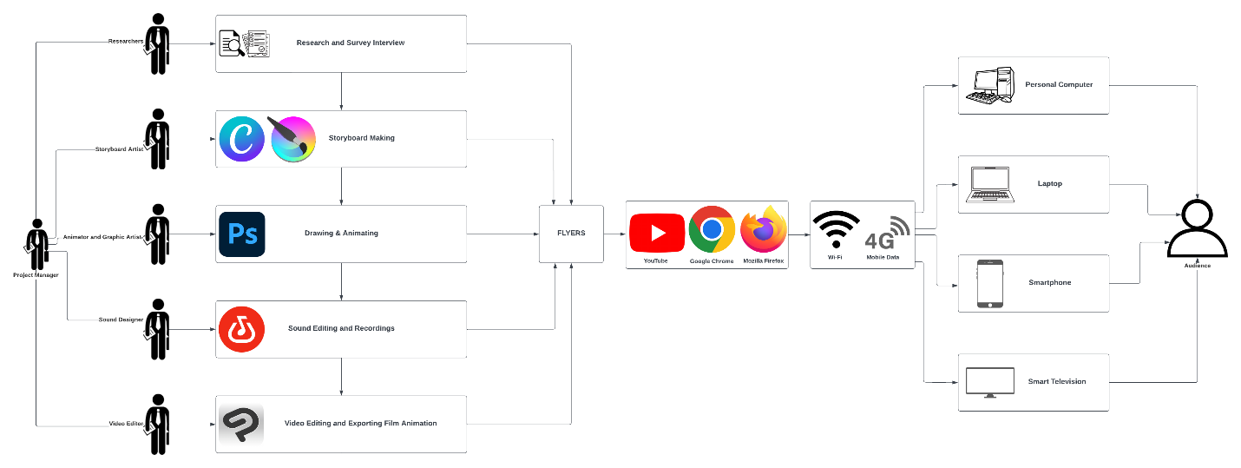 **Figure 2: Deployment Diagram**

The second figure provides an overview of the deployment phase of the project. During the process of the project, the project manager assigned and divided the work in five phases which are research and survey interview, storyboard making, drawing, and animating, sound editing and recordings, and video editing, and exporting the final film animation. These five-process division employed different multimedia software tools for their task; Canva, and Krita for storyboard making lead by the storyboard artist; Adobe Photoshop Pro for drawing and animating lead by the animator and graphic artist; BandLab for sound editing and recordings lead by the sound designer; lastly the Clip Studio Paint for the video editing and finalizing the entire film animation. The Habagat 2D Animated Film can be deployed by using different social media platforms such as YouTube. This animated film can be access through multiple devices as well, such as smartphone, smart television, laptops, and personal computers.

**3.3 VISUAL ASSETS**

**CHARACTERS**

**Figure 3 & 4: Character Design**

The third and fourth figure illustrates the character visual concept draft of the character, which usually involves incorporating essential elements like the shape of the face, hairstyle, and overall body shape. This phase emphasizes capturing the fundamental traits, attributes, gestures, emotions, different angles of the character while going into more specific aspects. The aim is to establish a base that can be expanded upon and enhanced in later stages of the character design process.

**BACKGROUNDS**



**Figure 5: Exterior of National University Manila campus Background**

The fifth figure provides a glimpse to the main character community as it will be one of the key settings that the characters will move around, and a view of the exterior part of the National University Manila campus. The various colors of the exterior of the university campus, and the sky creating a contrast between each other.

**Figure 6: Typhoon Crisis Scene Background**

The sixth figure provides a glimpse to the main character crisis as it will be one of the storyline processes that the characters will experience during the story. The various colors of the background, flood water, and the main character creating a contrast between each other.

**STORYBOARD**

Below are the animated timeline of the original concept and storyline of the film, “Habagat” produced by Francheska Nicole G. Limson. It consists of introduction, rising action, climax, falling action, and conclusion of the film animation.

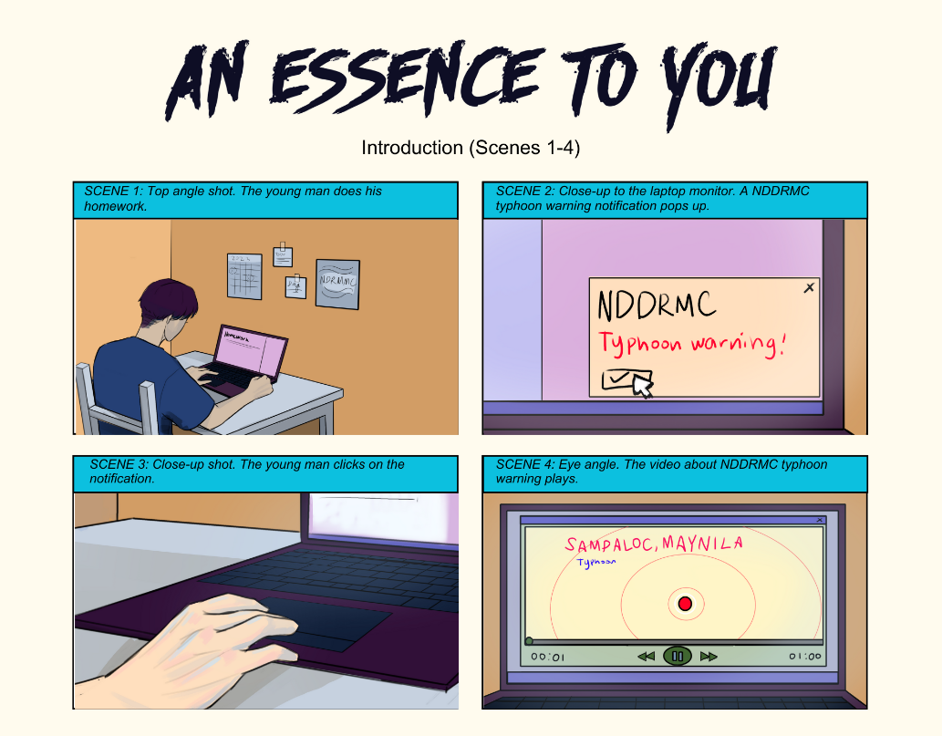

**Figure 7. Habagat - Introduction**

The seventh figure shows the first glimpse of the young boy who does his schoolwork, and suddenly he got an emergency notification from the NDDRMC involving a Typhoon Warning for the Barangay 407, Zone 42, Sampaloc, Manila area.

**STORYBOARD**

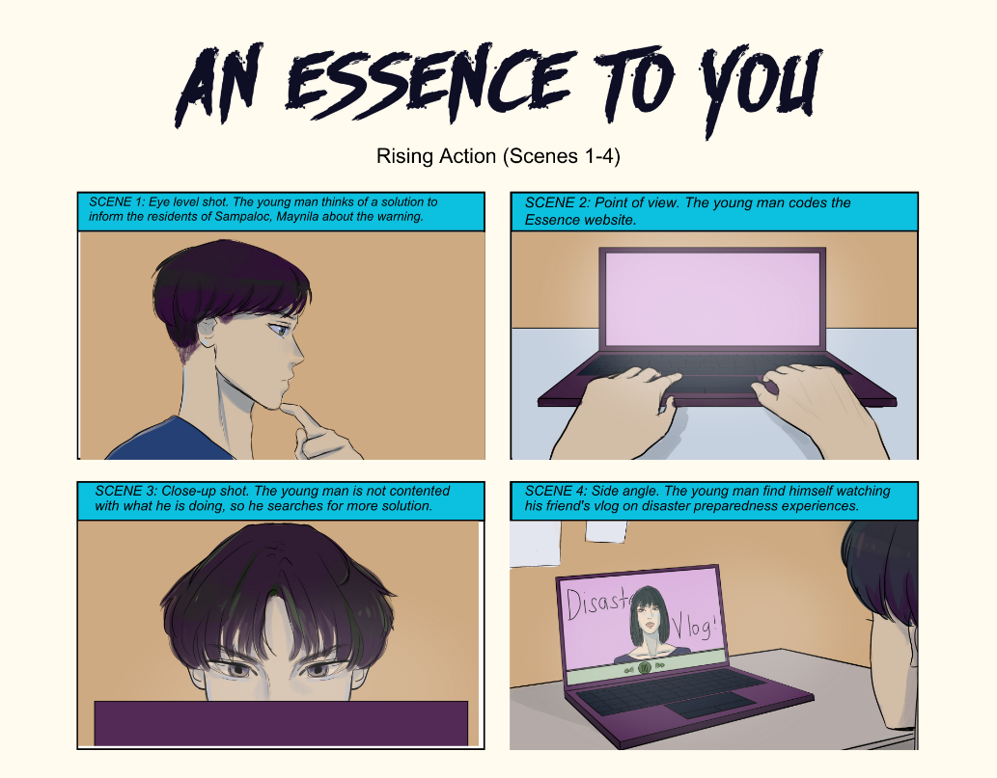

**Figure 8. Habagat – Rising Action**

The eighth figure shows that the teenager thinks of a solution to inform the residents of Sampaloc, Manila about the warning, then he codes a website called “Essence” but he’s not contented with what he did, so he searches for more solutions, and he find himself watching his friend’s vlog on disaster preparedness experiences.

**STORYBOARD**

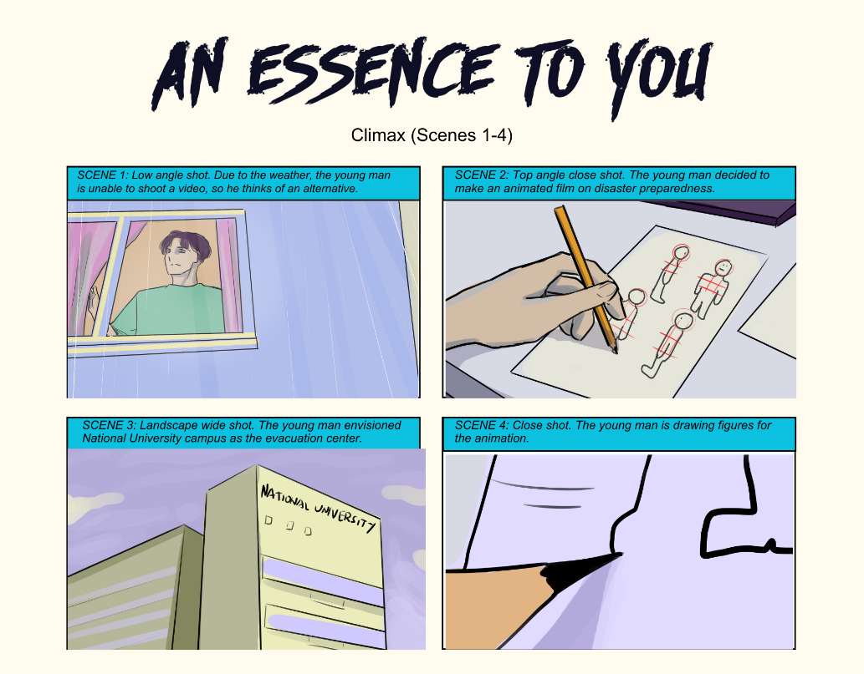

**Figure 9. Habagat – Climax**

The ninth figure shows that due to the weather, the young man is unable to shoot a video, so he thinks of an alternative. The young man decided to make an animated film on disaster preparedness. He envisioned National University Manila campus as the evacuation center and started to draw some figures for the animation.

**STORYBOARD**

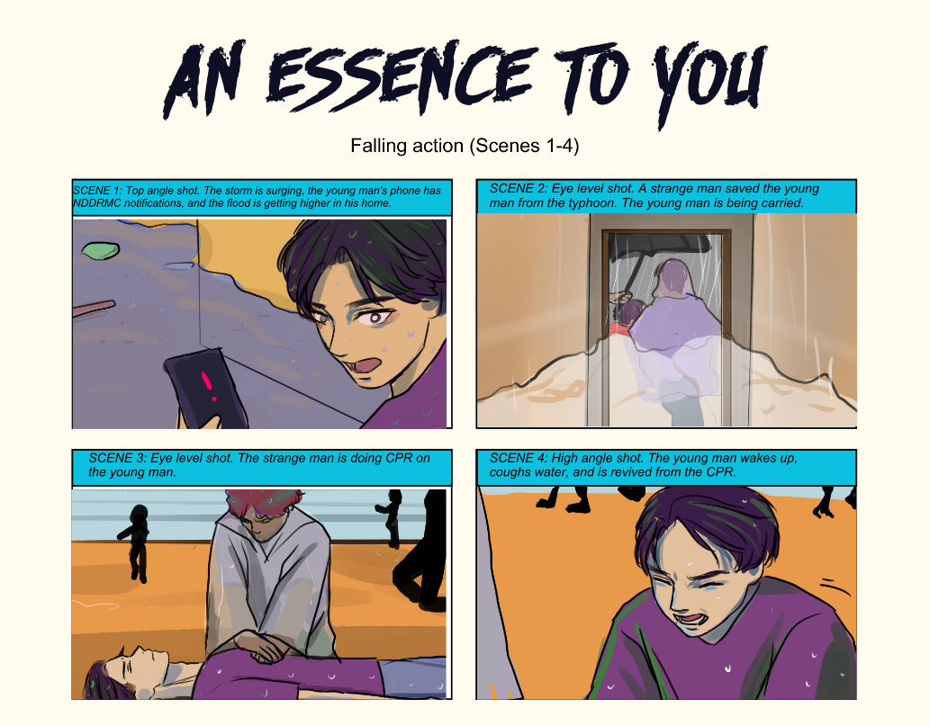

**Figure 10. Habagat – Falling Action**

The tenth figure shows that the storm is surging, suddenly the young man’s phone has received some emergency notifications from NDDRMC, and the flood is getting higher inside his home. A strange man saved the young man from the typhoon, and the young man is being carried, also he’s doing a CPR on the young man, and then he wakes up, coughs water, and revived from the CPR.

**STORYBOARD**

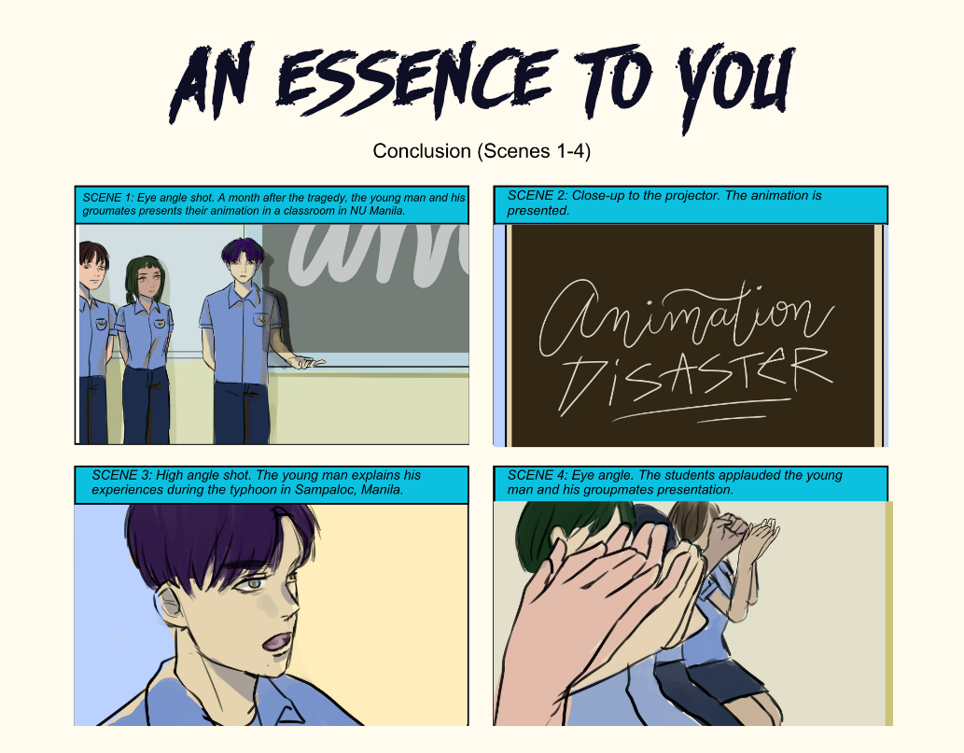

**Figure 11. Habagat - Conclusion**

The eleventh figure shows a month later after the tragedy, the young main and his groupmates presents their animation in a classroom for their thesis defense and presents the animation disaster preparedness film to their college classmates. The young man explains his experiences during the typhoon in Sampaloc, Manila. After their presenting their work output, the students applauded their presentation.

**SOUND EDITING**

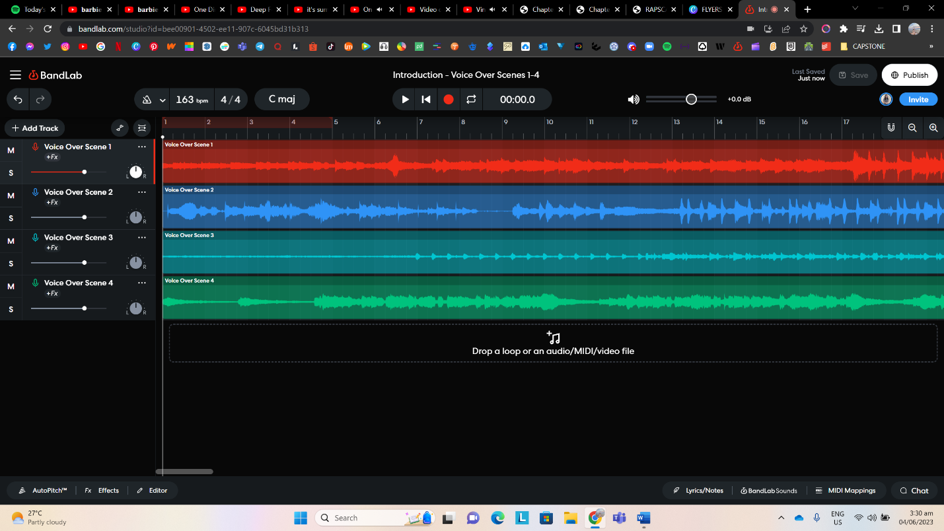

**Figure 12. BandLab workstation**

The twelfth figure shows the voice overs of the film that were produced through band lab. These voice overs for the scenes in introduction part are inspired by the original storyline concept of “Habagat” by Francheska Nicole G. Limson. The goal of the film is to raise awareness and educate the people in the vulnerable communities in the Philippines during typhoon occurs.

**WEBSITE**

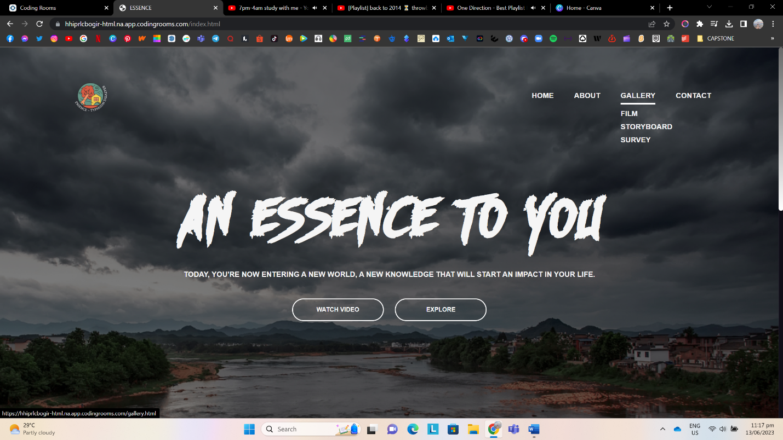 **Figure 13. Essence Website**

The thirteenth figure shows the website named “Essence”, that would give knowledge about the improving community disaster preparedness during typhoon events. This shows the home page, about page, gallery page, and contact page. In this site, it also includes the film animation “Habagat”, and the post-online survey link form under the gallery page.

**REFERENCES**

2021 Philippines Disaster Management Reference Handbook - Philippines. (2021). Retrieved from <https://reliefweb.int/report/philippines/2021-philippines-disaster-management-reference-handbook>

Adobo Magazine. (2020). Film: To Calm the Pig Inside A Story on the Effects of Super Typhoon Haiyan to Tacloban Premieres in Slam dance Film Festival. Retrieved from <https://www.adobomagazine.com/global-news/film-to-calm-the-pig-inside-a-story-on-the-effects-of-super-typhoon-haiyan-to-tacloban-premieres-in-slamdance-film-festival/>

Aljibe T. (2018). Philippines: Five years after Typhoon Haiyan. Retrieved from <https://www.theguardian.com/artanddesign/2018/nov/06/philippines-five-years-after-typhoon-haiyan>

Andrade J. (2022). Teen/Young Adult Transitional home status after the Typhoon. Retrieved from <https://cebushelter.org/blog/676/teen-young-adult-transitional-home-status-after-the-typhoon?gclid=CjwKCAjwrpOiBhBVEiwA_473dB7lrYuozxKB6i8WbGN-FTlMmu8M7V0hhde5KNbXPAb4NIc-SfeUYhoCLgQQAvD_BwE>

Beltran M. (2022). Successive storms leave Filipino farmers wanting better response and aid. Retrieved from <https://www.thenewhumanitarian.org/news-feature/2022/11/11/Philippines-storm-Nalgae-farmers-climate-change>

Cabico G. K. (2022). Typhoon hinnamnor seen to enter Par Wednesday. Philstar.com. https://www.philstar.com/headlines/2022/08/30/2206137/typhoon-hinnamnor-seen-enter-par-wednesday

Chi C. (2023). Typhoon-devastated Filipinos are vulnerable to trafficking - UN report. Philstar.com. https://www.philstar.com/headlines/2023/02/03/2242327/typhoon-devastated-filipinos-are-vulnerable-trafficking-un-report

Commoner. (2021). Why the time is ripe for animation in Philippine feature-length films. Medium. https://mediacommoner.medium.com/why-the-time-is-ripe-for-animation-in-philippine-feature-length-films-4e348c2a3515 [8]

Data vs disaster: Inside the Philippines' natural emergency preparedness programme. (n.d.). Retrieved from <https://govinsider.asia/intl-en/article/data-vs-disaster-inside-the-philippines-natural-emergency-preparedness-programme-undp-philippines>

Gabaldon V. (2022). Five things you need to know about the response to Typhoon rai in the Philippines. Retrieved from <https://connectingbusiness.org/news-events/blog/five-things-you-need-know-about-response-typhoon-rai-philippines>

Gamboa R. (2022). Preparing for bigger storms. Retrieved from <https://www.philstar.com/business/2022/11/01/2220585/preparing-bigger-storms>

Gonzalo Ladera L. A. & Tiemroth A. (2021). Typhoon disaster response amid the covid-19 pandemic: A case study of successive typhoons in the Philippines in 2020. Typhoon Disaster Response amid the COVID-19 Pandemic: A Case Study of Successive Typhoons in The Philippines in 2020. Retrieved from http://lup.lub.lu.se/student-papers/record/9058385

Granstrom S. (2022). Disaster Risk Reduction and Management in Metro Manila Philippines. Retrieved from <https://diva-portal.org/smash/get/diva2:1680923/FULLTEXT01.pdf>

Gumasing M. Prasetyo Y. Ong A. Nadlifatin R. & Persada S. (2022). Determining factors affecting the perceived preparedness of super typhoon: Three broad domains of Ergonomics Approach. Retrieved from <https://www.mdpi.com/2071-1050/14/19/12202>

Jepoy Montero. (2022). BAGYO EXPERIENCE ft @yokify & @VinceAnimation Pinoy Animation [Video]. YouTube. <https://www.youtube.com/watch?v=8eFbGCxGIBk>

Knowledge Channel. (2014). Bagyo at Baha | Disaster Preparedness [Video]. YouTube. <https://www.youtube.com/watch?v=2JihPYiSOac>

McCarthy J. & Storel M. (2021). Desperation grows in the Philippines in the aftermath of Typhoon Rai. Retrieved from <https://www.npr.org/sections/pictureshow/2021/12/20/1066049450/super-typhoon-rai-leaves-a-path-of-devastation-and-uncertainty>

Mideksa S. (2021). Cognitive factors as determinants of typhoon preparedness among public high school students in the Philippines. Retrieved from <https://www.ncbi.nlm.nih.gov/pmc/articles/PMC8512931/>

Murga A. (2022). Filipinos count cost of climate crisis as typhoons get ever more destructive. The Guardian. https://www.theguardian.com/global-development/2022/jan/05/filipinos-count-cost-of-climate-crisis-as-typhoons-get-ever-more-destructive

PDRF boosts QC barangays' disaster preparedness - Philippines. (2022). Retrieved from <https://reliefweb.int/report/philippines/pdrf-boosts-qc-barangays-disaster-preparedness>

Reid K. (2023). 2013 Typhoon Haiyan: Facts and how to help. Retrieved from <https://www.worldvision.org/disaster-relief-news-stories/2013-typhoon-haiyan-facts>

Rogayan D. Jr. (2020). Disaster awareness and preparedness of barrio community in Zambales. Retrieved from <https://www.researchgate.net/publication/341111393_Disaster_Awareness_and_Preparedness_of_Barrio_Community_in_Zambales_Philippines_Creating_a_Baseline_for_Curricular_Integration_and_Extension_Program>

SHED. (2021). Animated video on “Disaster Preparedness” [Video]. YouTube. <https://www.youtube.com/watch?v=s7PiMuzprCY>

Simonette V. (2020). Typhoon Goni: Philippines survivor tells of Children swept away. BBC News. <https://www.bbc.com/news/world-asia-54836809>

Typhoon Goni: Philippines hit by year's Most powerful storm. (2020). Retrieved from <https://www.bbc.com/news/world-asia-54759868>

Yuvallos A. (2022). Typhoon prep: What to do before, during and after. Retrieved from https://nolisoli.ph/103949/typhoon-guide-before-during-after/#:~:text=Right%20before%20a%20typhoon%20hits water%20for%20them%2C%20as%20well

Zoleta V. (2022). Typhoon preparedness tips to keep your loved ones safe. Retrieved from https://www.moneymax.ph/lifestyle/articles/typhoon-in-the-philippines